Parth Babbar

capital market advisory

Aim:
The Capital Market Advisory study seeks to research and give insights into the performance, trends, and key indicators of advisory services for stock offerings, debt issuances, and other capital market operations in the United States. This report promotes data-driven choices by presenting crucial data points while also highlighting the firm's market position and client interaction.
Features:
- Year: The calendar year in which the transactions or occurrences happened.
- Total_Equity_Offerings_Advised_MillionUSD: The total value of equity offerings advised by the company, expressed in millions of US dollars.
- Total_Debt_Issuances_Advised_MillionUSD: The total amount of debt issuances recommended by the company, expressed in millions of US dollars.
- Market_Share_Equity_Percent: The proportion of the market in which the company advises on equity issues.
- Market_Share_Debt_Percent: The firm's market share in advising on debt issuances.
- Secondary_Offerings_Trend: Indicates whether secondary offerings are rising, declining, or steady.
- Regulatory_Changes: The magnitude of regulatory changes influencing capital markets, classified as minimal, moderate, or significant.
- Investor_Sentiment: The overall mood or attitude of investors toward the market, classified as positive, neutral, or negative.
- Market_Outlook_Indicators: The overall market outlook, characterized as optimistic, bearish, or neutral.
- Number_of_Transactions_Equity: The number of equity transactions advised by the company in a particular year.
- Number_of_Transactions_Debt: The number of debt transactions recommended by the company over a particular year.
- Average_Deal_Size_Equity_MillionUSD: The average size of equity transactions advised by the firm in millions of US dollars.
- Average_Deal_Size_Debt_MillionUSD: The average size of debt deals recommended by the company, expressed in millions of US dollars.
- Number_of_Advisory_Clients: The number of clients who used the firm's advising services in a particular year.
- Revenue_from_Advisory_Services_MillionUSD: The total income earned by advisory services, expressed in millions of US dollars.
- Number_of_IPOs_Advised: The number of initial public offerings (IPOs) that the company advises in a particular year.
- Number_of_MA_Deals_Advised: The number of mergers and acquisitions (M&A) transactions advised by the company within a particular year.
- Success_Rate_Advised_Transactions_Percent: The proportion of suggested transactions that were completed successfully.
Methodology:
- Data Collection: The dataset for this research was created using synthetic data techniques to simulate real-world transactions in the US capital markets. The data contains a variety of measures that are critical for assessing the performance and trends in advising services.
- Data Preparation:
1.Data Cleaning: I ensured that the dataset was consistent and accurate. We checked for missing numbers and abnormalities.
2.Data Transformation: The data was reformatted into an appropriate framework for analysis, which included classifying patterns and attitudes.
- Data analysis:
1.Trend Analysis: Tracked historical trends in total stock and debt issues, market share, secondary offers, and regulatory changes.
2.Sentiment Analysis: Used investor sentiment and market outlook indicators to better comprehend market circumstances.
Output:
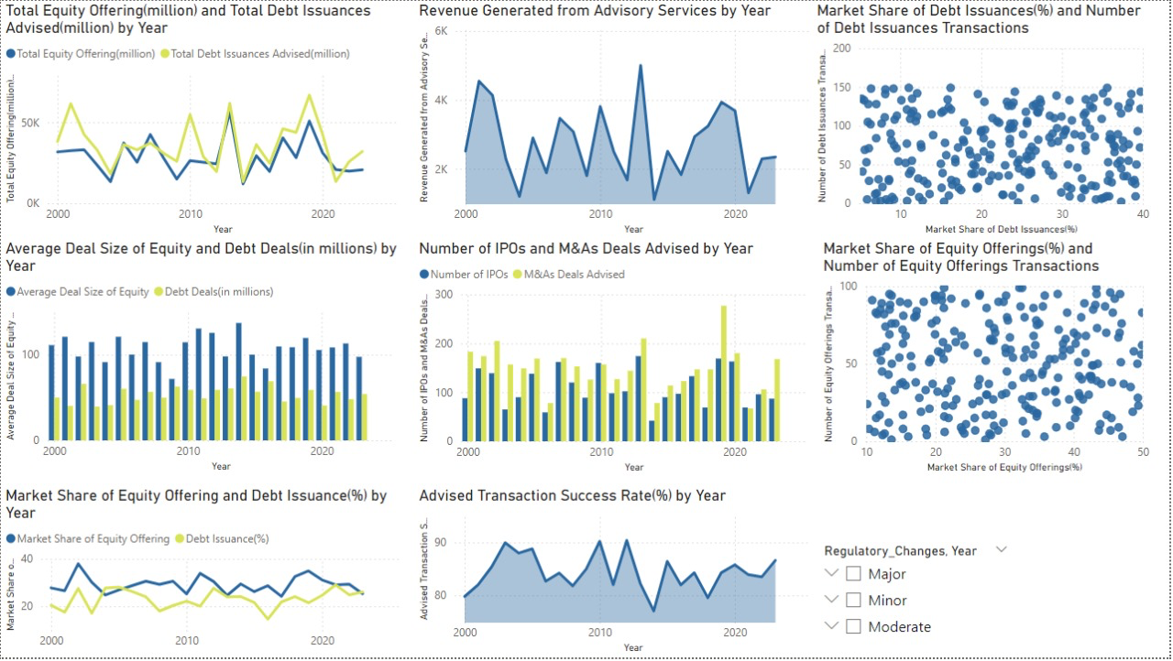
Result Analysis:
- Total Equity Offerings and Debt Issues Advised (Million USD) by Year:
1.Observation: Fluctuations in equity offers and debt issuances are visible, with equity peaks in 2007, 2010, and 2018, and debt peaks in 2009, 2015, and 2018.
2.Insight: Trends are likely impacted by events such as the 2008 financial crisis and subsequent recovery phases. Peaks in 2018 point to increased US capital market activity.
- Revenue From Advisory Services by Year:
1.Observation: Revenue varies, increasing around 2007, 2010, and 2015, and declining after 2020.
2.Insight: Revenue corresponds with equity and debt advisory patterns, which are driven by market circumstances. The post-2020 fall might be attributed to market concerns, which are likely worsened by the COVID-19 pandemic.
- Market Share of Debt Issuances (%) and the number of debt issuance transactions:
1.Observation: Market share percentages are concentrated between 10 and 30%, with greater market shares often indicating more transactions.
2.Insight: Firms with larger market shares handle more transactions, implying that market dominance is related to transaction volume in US debt issuances.
- Average Deal Size for Equity and Debt Deals (Million USD) by Year:
1.Observation: The average transaction size for equity agreements is often larger than that of debt deals, with both demonstrating relative consistency and slight changes over time.
2.Insight: stock agreements require more cash than debt ones, indicating possibly greater values or more significant funding demands in stock markets.
- Number of IPOs and M&A Deals Advised By Year:
1.Observation: Both IPOs and M&A agreements are on the rise, with peaks around 2007 and 2010, followed by a considerable increase after 2015.
2.Insight: Increased IPO and M&A activity indicates more market involvement and investor confidence. The surge after 2015 is likely due to improved economic circumstances and market liquidity in the United States.
- Market share of equity offerings (%) and the number of equity offering transactions
1.Observation: Higher market shares in stock offerings correspond to a higher number of transactions, which typically range between 10 and 40%.
2.Insight: Market share dominance in stock offers is related to transaction volume, implying that leading businesses handle a higher amount of equity transactions.
- Market Share of Equity Offerings and Debt Issues (%) by Year:
1.Observation: Market share percentages for both stock and debt vary, with equity offers having more prominent peaks and troughs than debt issuances.
2.Insight: Variability represents competitive movements and changing market dynamics in the United States, as driven by macroeconomic conditions, regulatory changes, and corporate strategy.
- Advised Transaction Success Rate (%) each Year:
1.Observation: The success percentage of suggested transactions varied, with a large drop in 2008 and a subsequent rebound, stabilizing around 80-90% in recent years.
2.Insight: The 2008 slump coincided with the financial crisis, emphasizing the difficulties of economic downturns. Recovery indicates better market conditions and more effective advice methods.
Summary:
The Capital Market Advisory dashboard provides a detailed examination of the US capital markets, focusing on the interplay of economic conditions, regulatory changes, and competitive dynamics. The key findings show a high link between market share and transaction volume, with bigger deal sizes reported in stock transactions. The data covers many decades and captures the influence of major economic events and regulatory changes. This thorough research provides stakeholders with vital insights for informed decision-making and strategic planning, guaranteeing a solid awareness of market trends and circumstances in the capital market advising industry.

